
Tribhuvan University
Faculty of Humanities and Social Sciences

ROOM RENTAL SERVICE

A PROJECT REPORT

Submitted to
Department of Computer Application
NIMS College
Kumaripati, Lalitpur

In partial fulfillment of the requirements for the Bachelor in Computer Application

Submitted by

Sanjaya Kumar Giri
BCA 4 th Semester
Symbol No.: 75602080
2081/10/15

Under the Supervision of
Nirmala Timalsina



Tribhuvan University
Faculty of Humanities and Social Sciences
Nims College

Supervisor’s Recommendation

I hereby recommend that this project prepared under my supervision by Sanjaya Kumar giri entitled “ONLINE VOTING SYSTEM” in partial fulfillment of the requirements for the degree of Bachelor of Computer Application is recommended for the final evaluation.

…..................................................
NIRMALA TIMALSINA
SUPERVISOR
Nims College
BCA
Kumaripati, Lalitpur

Tribhuvan University
Faculty of Humanities and Social Sciences
Nims College
Kumaripati, Lalitpur

LETTER OF APPROVAL

This is to certify that this project prepared by SANJAYA KUMAR GIRI entitled “ONLINE VOTING SYSTEM” in partial fulfillment of the requirements for the degree of Bachelor in Computer Application has been evaluated. In our opinion, it is satisfactory in the scope and quality as a project for the required degree.

…..................................................  Nirmala Timalsina (Supervisor)  BCA  Nims college  Kumaripati, Lalitpur | …..................................................  Shyam Thapa Magar(HOD of BCA)  BCA  Nims college  Kumaripati, Lalitpur
…..................................................  Nirmala Timalsina  Internal Examiner | …...............................................…  External Examiner

Abstract
The Online Voting System is a web-based application developed using PHP for backend processing, HTML/CSS for frontend design, and JavaScript for dynamic and interactive features. This system allows users to register themselves, update their profiles (username, password, and mobile number), and participate in elections effortlessly. Admins can create and manage elections, handle candidate registrations, and delete users. Candidates can select the election post they wish to compete for. Elections are time-limited, and results are automatically displayed on both user and admin dashboards after the election ends. JavaScript enhances user experience by providing interactive elements like real-time validations and dynamic content updates, making the system user-friendly, secure, and efficient for quick and transparent elections.
.
Keywords: Online Voting, PHP, HTML, CSS, JavaScript, User Registration, Admin Panel, Candidate Management, Dynamic Features, Secure Voting, Automatic Results, Real-Time Validation

Acknowledgment
The number of people helping me with my projects deserves a lot of thanks and consideration. Special thanks go to Nirmala Timalsina for guiding me to do this project and helping with documentation. Special thanks to my parents as well for helping me in a lot of ways in this project in regards to time, economy, comments, and many more. Enough cannot be expressed but thanks to my peers and teachers for helping me with little suggestions.
All the work done in this system is dedicated to my family for being part of me in the whole process, especially our dear friends who stood by me in all situations. Finally, thanks to YouTubers, bloggers, github users, stack overflow community, developers, and every technical information provider for making this project possible.

Yours sincerely,

Sanjaya Kumar Giri

TABLE OF CONTENTS

SUPERVISOR’S RECOMMENDATION
LETTER OF APPROVAL
ABSTRACT i
ACKNOWLEDGEMENT ii
LIST OF ABBREVIATIONS v
LIST OF FIGURES vi
LIST OF TABLES vii
CHAPTER: 1 INTRODUCTION 1
1.1 Introduction 1
1.2 Problem Statement 1
1.3 Objectives 2
1.4 Scope and Limitation 2
1.5 Development Methodology 3
1.6 Report Organization 3
CHAPTER: 2 BACKGROUND STUDY AND LITERATURE REVIEW 4
2.1 Background Study 4
2.2 Literature Review 4
CHAPTER: 3 SYSTEM ANALYSIS AND DESIGN 6
3.1 System Analysis 6
3.1.1 Requirement Analysis 6
3.1.2 Feasibility Analysis 6
3.1.3 Data Modeling: ER Diagram 10
3.1.4 Process Modeling DFD 11
3.2 System Design 14
3.2.1 Architectural Design 14
3.2.2 Interface Design 15
3.2.3 Physical DFD 15
3.3 Algorithm details 16
CHAPTER: 4 IMPLEMENTATION AND TESTING 17
4.1 Implementation 17
4.1.1 Tools Used 17
4.1.2 Implementation details of Modules 18
4.2 Testing 19
4.2.1 Test Cases for Unit Testing 19
Table 1: Unit Testing 20
4.2.2 Test Cases for System Testing 21
CHAPTER: 5 CONCLUSION AND FUTURE RECOMMENDATIONS 25
5.1 Conclusion 25
5.2 Lesson Learnt 25
5.3 Future Recommendation 25
APPENDICES 27
REFERENCES 32

LIST OF ABBREVIATIONS

Abbreviation | Meaning
K-NN  WWW  GHz  IDE  JSON  API  RAM  URL  DB  DFD  CASE  E-Commerce  ER | K Nearest Neighbor  World Wide Web  Gigahertz  Integrated Development Environment  JavaScript Object Notation  Application Program Interface  Random Access Memory  Uniform Resource Locator  Database  Data Flow Diagram  Computer-Aided Software Engineering  Electronic Commerce  Entity Relationship

LIST OF FIGURES
Figure 0: Development methodology 3
Figure 1: Use Case Diagram 7
Figure 2: Gantt chart for Room Rental Servive 9
Figure 3: ER Diagram 10
Figure 4: Level 0-DFD 11
Figure 5:Level 1-DFD 12
Figure 6: Level 2-DFD 13
Figure 7: Architectural Design 14
Figure 8: Interface Design-admin 15
Figure 9: physical DFD 15

LIST OF TABLES
Table 1: Gantt chart for Room Rental Servive 8
Table 2: Unit Testing 20
Table 3: System Testing-login 21
Table 4: System Testing-registration 23
Table 5: System Testing-Add To Cart button 24

CHAPTER: 1

INTRODUCTION

Introduction

In the modern age of technology, the internet has become an integral part of daily life, simplifying tasks and improving accessibility. With advancements in online systems, traditional voting processes are transitioning to digital platforms for greater convenience and efficiency. The Online Voting System is designed to address the challenges of managing elections by providing a secure, fast, and transparent voting process for both users and administrators. [1]This system allows users to register themselves, update their profiles, and participate in elections from anywhere with an internet connection. Admins can create and manage elections, define time durations, and handle candidate registrations. Candidates can select their desired election posts, and results are automatically published for both users and administrators after the election period ends. The system benefits all participants by making the voting process simple, reliable, and accessible. For administrators, managing elections becomes more organized and efficient, while voters enjoy the convenience of participating remotely. With dynamic features powered by PHP, JavaScript, HTML, and CSS, the system ensures a user-friendly and secure experience for all.

Promoting smart technology, this system helps organizations, institutions, and communities streamline their election processes and encourages greater participation through its intuitive design. Registration is mandatory for all users, ensuring a structured record-keeping and enhancing system integrity.

1.2 Problem Statement
Traditional voting methods like paper-based or in-person voting can be slow, inconvenient, and prone to mistakes. People may find it hard to vote due to distance, long queues, or scheduling conflicts, leading to low voter participation. For election administrators, managing everything manually is time-consuming and increases the chances of errors in counting votes or verifying voter details.

There is a need for an easy-to-use, secure online system where people can vote from anywhere, and admins can manage elections quickly and accurately. The Online Voting System solves these issues, making voting faster, more accessible, and reliable for everyone involved.

1.3 Objectives
The objectives of the online voting system application are as follows:
- Ensure Secure User Authentication: Implement a robust login system to securely authenticate users, protecting their personal information and ensuring only authorized individuals can access the voting platform.
- Efficient Election Management: Provide a streamlined interface for administrators to easily manage and display available elections, allowing users to view, select, and participate in relevant elections.
- Facilitate a Seamless Voting Mechanism: Allow users to cast votes for their preferred candidates or options with ease, ensuring the voting process is simple, secure, and error-free.
- User-Friendly Dashboard for Voting Status: Offer a user-friendly dashboard that provides users with real-time updates on their voting status and easy navigation through the system, enhancing their overall experience.

1.4 Scope and Limitation
1.4.1 Scope
- Secure user registration and login to ensure only authorized access..
- Admins can create, manage, and update elections with customizable settings.
- Users can easily cast votes securely and anonymously for candidates or options.
- Automatic vote tallying and real-time result display on user and admin dashboards.
- Protection of voter information using encryption and secure protocols.
- Personalized dashboard for users to manage profiles and track voting history..

1.4.2 Limitation
The Online Voting System has a few limitations. It depends on internet access, which can be an issue for people in areas with poor or no connection. Technical problems like system crashes or bugs could disrupt voting and delay results. Even though security is in place, there's always a risk of hacking or data leaks, which could affect voter information. Verifying voters accurately can also be tough, as fake registrations or weak security may cause issues. The system might be difficult for people who aren't tech-savvy, making it less accessible for some. Legal rules may prevent the system from being used in certain areas or elections. Lastly, some people might not trust online voting, which could lower participation.

1.5 Development Methodology
There are uncountable resources available as secondary sources and primary sources however this project is based more on Secondary sources like blogs, articles, books, official sites, and official materials. Tutorial videos from social media like YouTube, github, and Coursera assisted widely in developing this project. Primary sources like the project supervisor, peers, and teachers were valuable sources for conducting this project and its documentation. This project is based on prototype methodology due to the uncertainty of materials that may be in demand or to cope with the changes. However, this project had to be made ready by the end of the semester so the prototype was presented in the proposal, then again updated prototype was proposed in mid-defense, and so on.

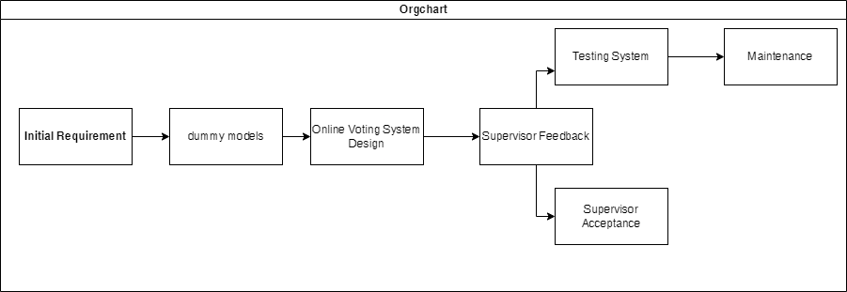

Figure 0: Development methodology

1.6 Report Organization
This report is organized in 5 different chapters based on the official documentation as per Tribhuvan University.

CHAPTER: 2
BACKGROUND STUDY AND LITERATURE REVIEW

2.1 Background Study
Voting is an important process in any democratic system, allowing people to choose their leaders and make decisions on key issues. Traditional voting methods often face problems like long waiting times, high costs, and the chance of errors or manipulation. These issues have led to the need for a better, more efficient solution.
With the rise of technology, online voting systems have become a practical alternative. They allow people to vote securely and conveniently from anywhere, making the process faster and easier. Online systems also reduce the need for physical resources, saving time and money while ensuring accuracy and transparency.
This project aims to create a PHP-based Online Voting System that solves these problems. The system includes features like secure user login, election management, and a simple way to cast votes. It also has a dashboard where users can check their voting status and view details about elections.
By making voting more accessible and efficient, this system shows how technology can improve traditional voting methods and encourage more participation.

2.2 Literature Review
Online voting systems have been studied as a way to address the limitations of traditional voting methods, such as delays, errors, and high costs. Research highlights that these systems can improve efficiency, accessibility, and security by leveraging technologies like secure login, data encryption, and user-friendly interfaces. Previous systems have demonstrated the potential to increase voter participation, especially for those unable to access physical polling stations. However, challenges like ensuring system security, maintaining voter anonymity, and managing technical issues remain key concerns. Existing works, including smaller-scale implementations for board meetings and student councils, have provided valuable insights into balancing simplicity for users with robust security measures. This project builds on these findings, aiming to create a practical and reliable PHP-based online voting system.
CHAPTER: 3

SYSTEM ANALYSIS AND DESIGN

3.1 System analysis
There are many functional and non-functional, internal and external components that build up this complete system and each of their roles is equally important to carry out different modules, testing, and partial deployment of the system so that it can be presented in the real world. Each and every module of a system is analyzed so that it passes every feasibility exam and produces a user-friendly and effective system.

3.1.1 Requirement Analysis
There were several requirements in this system and to make this system run well, using a device to do programming, programming language, real-world objects to implement and create the system, database to store the users, candidates, votes and admin records and data in this system.

Functional requirements
The Online Voting System must provide a secure and efficient platform for managing elections and enabling users to participate. The system requires user authentication to ensure that only registered users and administrators can access it. Admins should have the ability to create, update, and manage elections, while users can view active elections and cast their votes. Each user is allowed to vote only once per election, with their votes stored securely to maintain privacy and integrity. A user-friendly dashboard must be available for both users and admins, allowing voters to track their voting status and view election details, while admins can monitor election progress and manage the system. Additionally, the system must support accurate calculation and display of results, ensuring transparency and reliability. Notifications and alerts about upcoming elections and deadlines should be sent to users, while admins are notified of any system irregularities. The system must also ensure data security by encrypting sensitive information and maintaining logs of all activities. Finally, the system should be accessible across multiple devices through a web browser and provide an intuitive interface for seamless navigation.

Figure 1: Use Case Diagram

Non-functional requirements
The Online Voting System needs to meet several important requirements to work well. It should be fast, handling at least 100 users at once, with actions like logging in or voting taking no more than 2 seconds. The system should be reliable, with 99.9% uptime and daily backups to prevent data loss. It must also be able to handle more users and elections as it grows. Security is crucial, with encrypted data and protection against unauthorized access. The system should be easy to use on different devices and browsers, ensuring a smooth experience for everyone. It should be easy to maintain and update, with a clear and organized codebase. Additionally, it must comply with legal regulations and be accessible to users with disabilities. These requirements ensure the system is efficient, secure, and user-friendly.

3.1.2 Feasibility Analysis
This system is a feasible project. For testing feasibility, different factors were analyzed and evaluated to determine if this system is technically feasible, feasible with the estimated cost and profitability.

Technical Feasibility
The Online Voting System is technically feasible using widely available technologies. PHP will be used for server-side scripting, and MySQL will handle secure data storage. The front-end will use HTML, CSS, and JavaScript to ensure a responsive and user-friendly interface. These technologies are reliable, well-documented, and supported by a large community, making the development and deployment process straightforward. The system can be hosted on standard web hosting platforms, ensuring accessibility and scalability without requiring specialized infrastructure.

Operational
he Online Voting System is practical and easy to use in real-world settings. It has a simple and user-friendly interface, making it easy for users to log in, vote, and check their voting status. Administrators can manage elections and users without needing technical skills. The system is designed for easy maintenance, allowing regular updates and fixes without disruptions. It is scalable, so it can handle more users and elections as needed. The system also ensures data security and follows legal requirements to protect user information and maintain trust. With basic training and support available, the system can be smoothly operated and managed over time.

Economics
The economic feasibility of the Online Voting System evaluates whether the benefits of the system outweigh its costs, ensuring it is financially viable. The project minimizes costs by using free and open-source technologies like PHP, MySQL, and local hosting during development. This reduces the need for expensive software or hardware. Additionally, hosting the system locally eliminates ongoing hosting fees, making it cost-effective for small-scale use.
The system's benefits, such as saving time, reducing paper usage, and minimizing administrative costs, significantly outweigh the initial development expenses. By automating election processes, it eliminates the need for physical voting materials and manual counting, leading to long-term cost savings. The system's scalability also ensures that any future growth or expansion will be financially sustainable. Overall, the Online Voting System is an economically feasible solution for secure and efficient voting processes.

Task Name | Duration
Phase 1 | January 01
Phase 2 | February 01
Phase 3 | March 01
Phase 4 | April 01
Phase 5 | May 01

Table 1: Gantt chart table for Room Rental Service
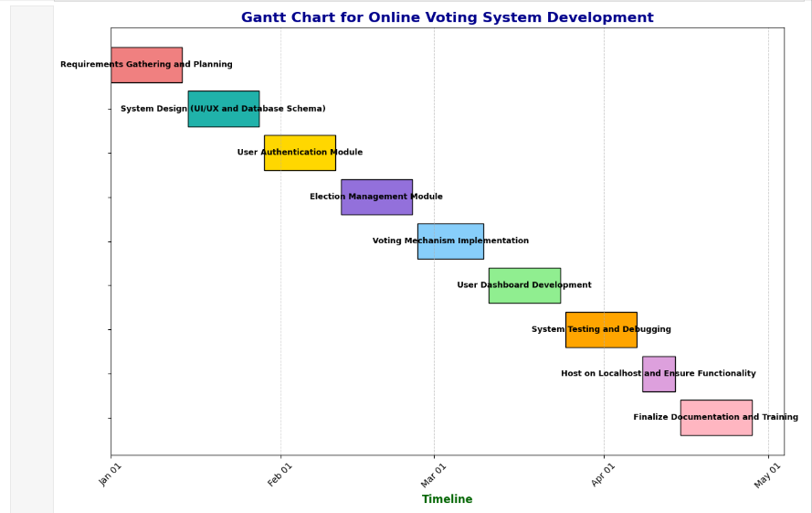

Figure 1: Gantt chart for Room Rental Service

3.1.3 Data Modeling: ER Diagram

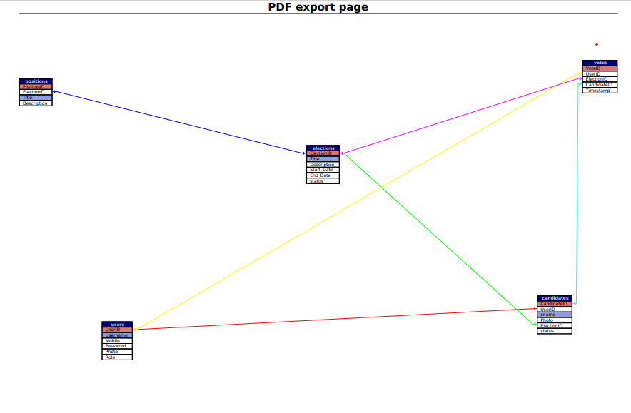
Figure 3: ER Diagram

3.1.4 Process Modeling DFD
To define the workflow or flow of data between several components I have created level 0, level 1, and level 2 Data flow diagrams illustrated below:

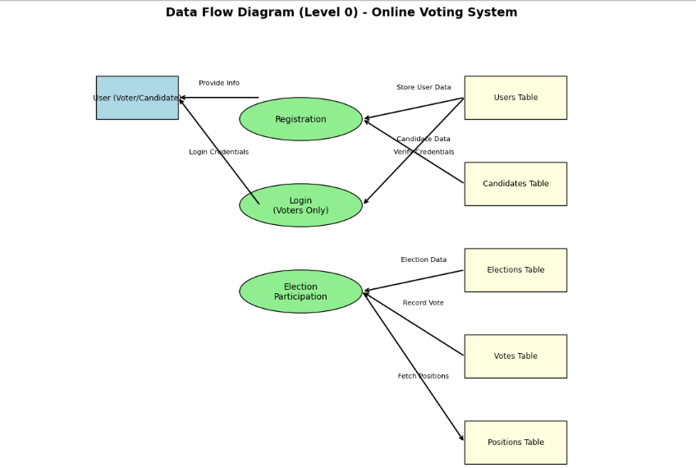
Figure 4: Level 0-DFD

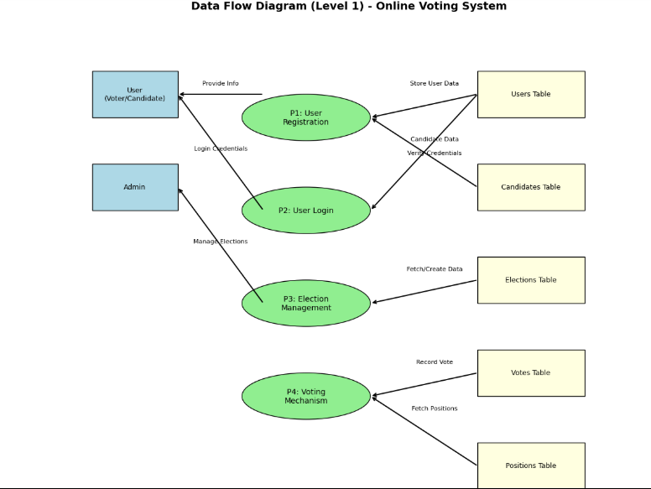
Figure 5: Level 1 -DFD

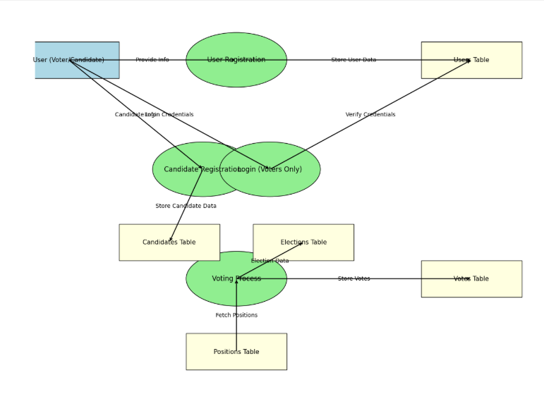
Figure 6: Level 2-DFD

3.2 System Design

3.2.1 Architectural Design
The architecture of this system is based on functional components that are integrated together to build a complete system.
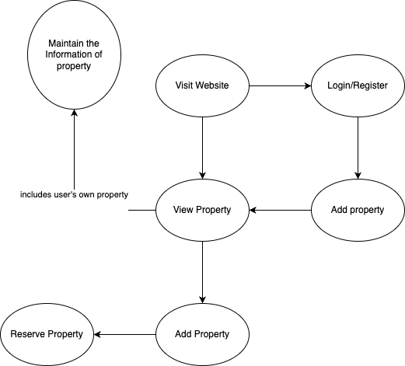
Figure 7: Architectural Design

3.2.2 Interface Design
In this project, there are three types of interfaces: a logged-in or registered user, a non-logged-in or non-registered user, and the admin can see and perform different calls to action on the available entities. The three different interfaces are illustrated below:
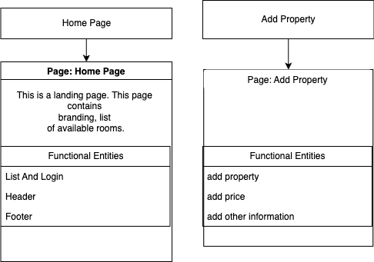S

Figure 8: Interface Design-admin

3.2.3 Physical DFD
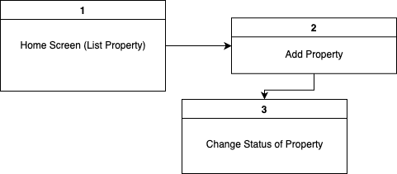

Figure 9: Physical DFD

CHAPTER: 4

IMPLEMENTATION AND TESTING

4.1.1 Tools used
Different tools which are in favor to complete the system building, planning, analyzing, designing. HTML ,CSS and JAVAScript used in front end, and PHP was used in back end while MySQL was used as a database.
Software and Hardware Used
MySQL- To store the database of user and admin like id, password and order details and system Data.
Sublime Text- The Sublime text is used for programming code.
Programming language- The programming languages like HTML, CSS, JS and PHP are used in this project.
Testing- The testing is done on the local server.
Designing- The designing of figures, logos were done on Canva and draw.io.
Web browsers- Microsoft Edge were used for testing this system.
Version Control System- GitHub All the source code of this project is available in GitHub and git was used to commit the changes made and update several components in every instance of time.
Processor: Built on Intel® Core™ i5-1335U CPU @ 1.30 GHz processor.
Memory: This system was developed on a device with 4GB RAM

4.1.2 Implementation details of modules
This system is made up of functional modules that are divided into components to ensure better readability, maintainability, and scalability. Since PHP is used for back-end development and follows a modular approach, building and understanding different components of the system is straightforward, reducing the chances of errors. The front-end is developed using HTML, CSS, and JavaScript, ensuring a responsive and user-friendly interface.

The client side consists of a homepage where users can view ongoing elections and available positions. It provides essential functionalities such as registering as a voter or candidate, logging in, and casting votes. The homepage is modularized into different sections, including the header, footer, and dashboard, allowing independent development and easier updates. While voters can log in to access the system and cast their votes, candidates are only allowed to register but cannot log in, ensuring a secure and fair election process.
The back-end technology used is PHP with MySQL for dynamic processing, authentication, and voting logic implementation. The system ensures secure voting mechanisms, prevents duplicate voting, and maintains data integrity. The asynchronous processing of requests ensures that multiple voters can cast their votes simultaneously without delays or conflicts.
For database management, MySQL is used, which is a reliable and scalable relational database system. It efficiently stores data such as user records, election details, candidate information, votes, and positions. Each entity is stored in a separate table (Users, Candidates, Elections, Votes, and Positions) to maintain structured and organized data storage. The system ensures data security by encrypting sensitive information and preventing unauthorized access
This modular approach allows for efficient system development and easy scalability, ensuring a seamless and transparent online voting experience.

4.2 Testing
This system was tested by friends, supervisors, and other teachers and the feedback is good. So that this system can be implemented in a real-time environment. Many important defects, flaws, or errors were caught up in the application code which is resolved now and this system is still in progress to be a better version.

4.2.1 Test cases for Unit Testing
In this testing individual pages, button, and functionality of a system is tested. Every module was tested to derive the best project for the deployment. Eventually, it helps to identify failures in the algorithms as well as logic to help improve the quality of the code that composes a certain function
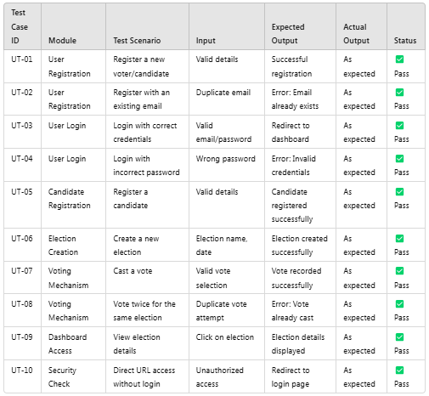

Table 1: Unit Testing

4.2.2 Test cases for System Testing
In this test I have tested the different modules as a whole by integrating them together to evaluate how the components are working together and showing their result in a group.
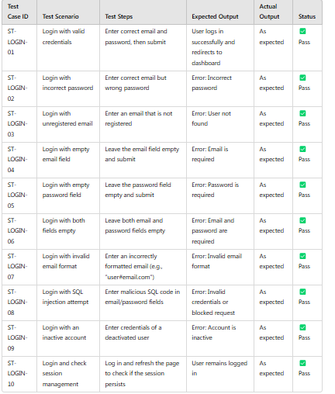
Table 2: System Testing-login

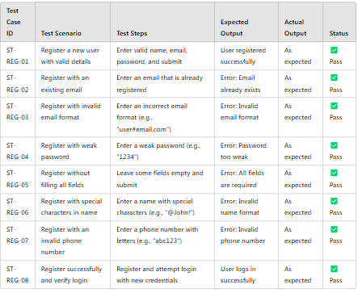
Table 3: System Testing-registration

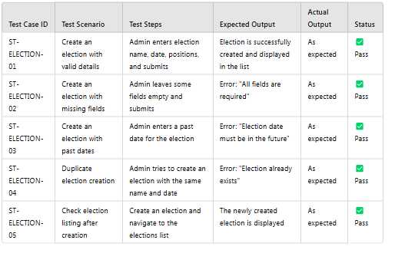
Table 4: System Testing for Creat Election
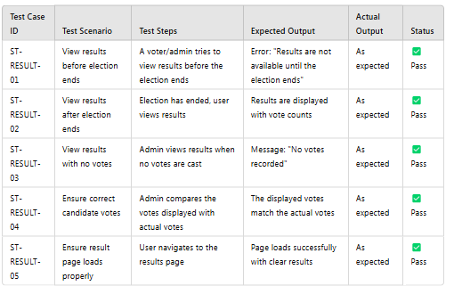
Table 5: System Testing for View Election Result

CHAPTER: 5

CONCLUSION AND FUTURE RECOMMENDATIONS
The Online Voting System provides a secure, efficient, and user-friendly platform for conducting elections digitally. The system ensures voter authentication, election management, and vote security, making the voting process more accessible and transparent. By leveraging PHP for back-end development and MySQL for data storage, the system effectively manages users, elections, and votes while maintaining data integrity. The modular design allows for easy scalability and maintainability, ensuring smooth operation even under high user loads.
The implementation of security measures such as user authentication, data encryption, and vote validation prevents unauthorized access and ensures fair elections. Overall, this system enhances convenience, transparency, and accessibility compared to traditional voting methods.

5.2 Lesson learn
Developing the Online Voting System enhanced my understanding of secure authentication, database management, and system modularization. I learned the importance of data integrity, security measures, and user experience. Implementing PHP, MySQL, and security protocols provided practical insights into building a scalable, efficient, and transparent digital voting platform.

5.3 Future Recommendation
To further improve the system, the following enhancements can be considered:
- Biometric Authentication – Implement fingerprint or facial recognition to enhance security and prevent identity fraud.
- Blockchain Integration – Using blockchain technology can ensure tamper-proof voting records, making elections even more transparent and secure.
- Real-Time Vote Counting – A feature to display vote counts in real time for improved transparency and efficiency.
- Multi-Factor Authentication (MFA) – Adding an extra layer of security by requiring email or SMS verification during login.
- Mobile Application Support – Developing a mobile-friendly version or a dedicated mobile app for easier access and usability.
- Cloud-Based Hosting – Hosting the system on the cloud to enhance accessibility and scalability, allowing for larger-scale elections.

APPENDICES
Landing page When Admin Login
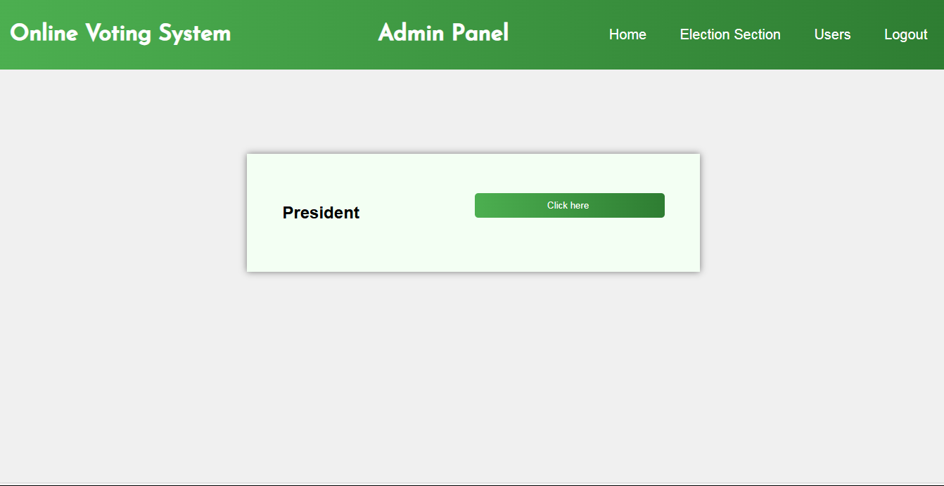

Voter And Candidate List Page
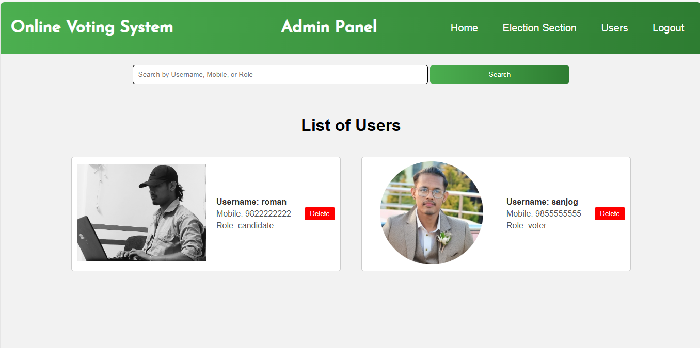

Source code
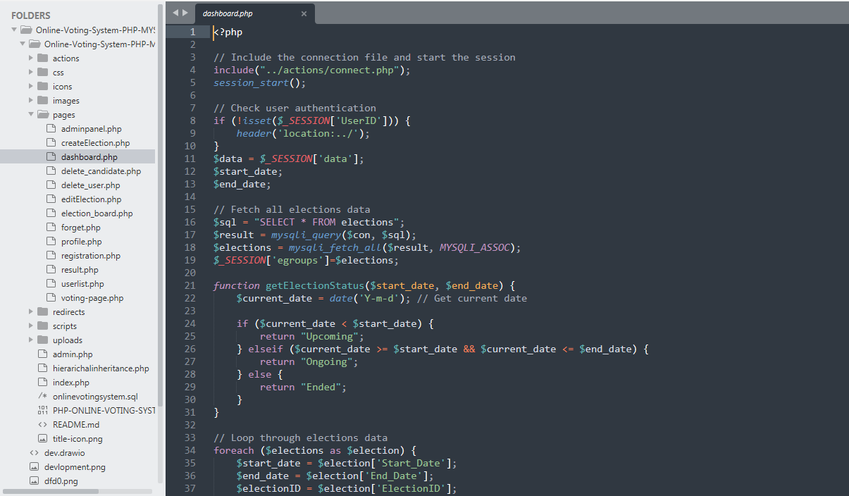

Election Create Page
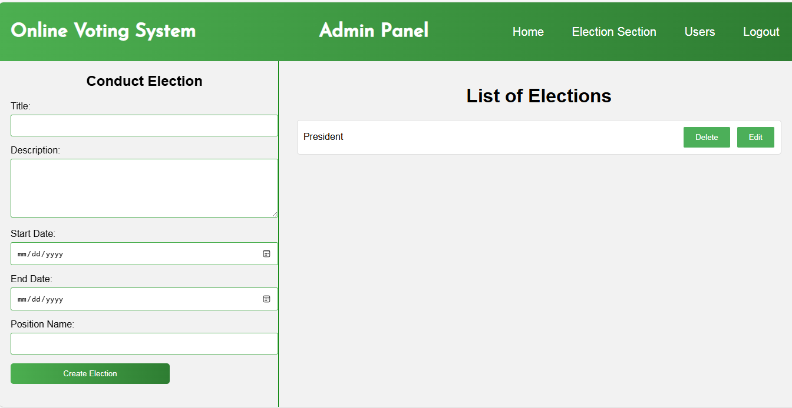
Register voter and candidate page

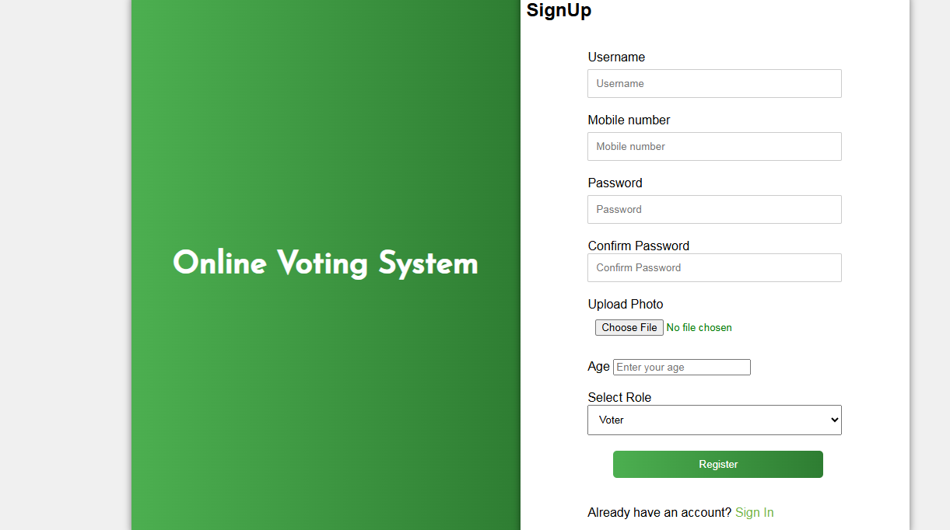

Login Page
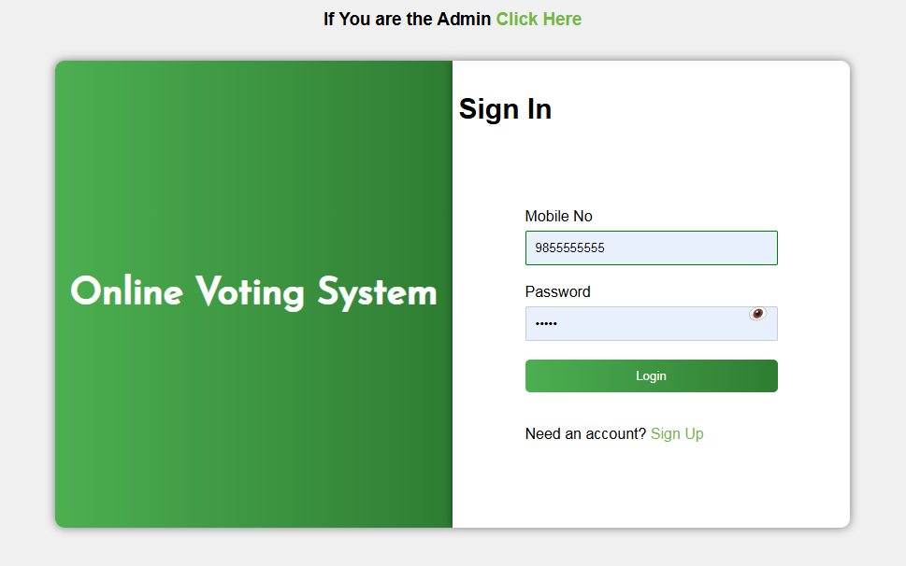
Source code
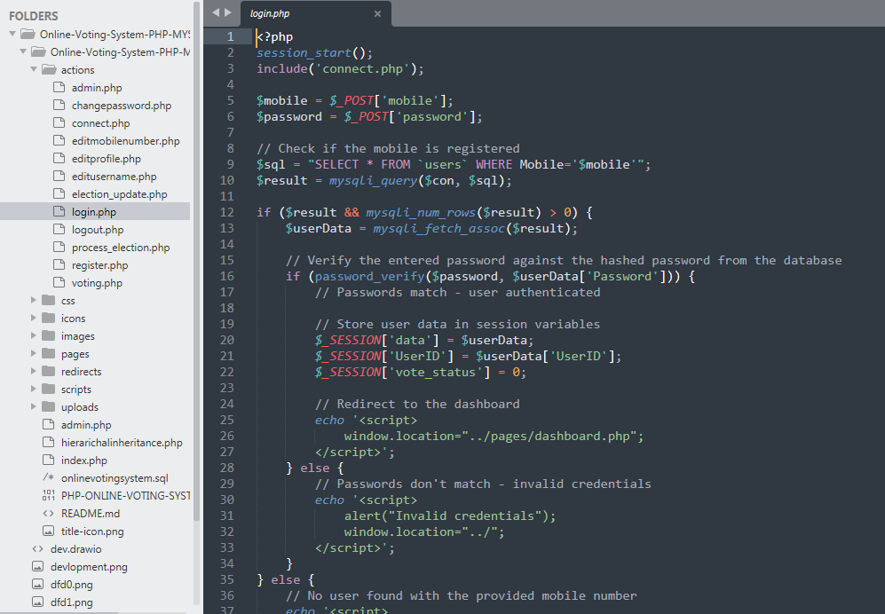
User Dashboard
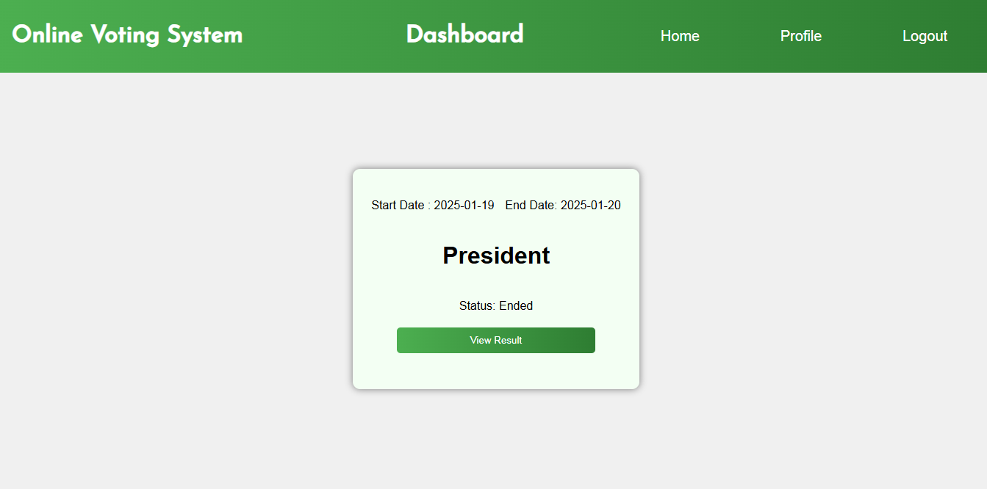

User Password Reset
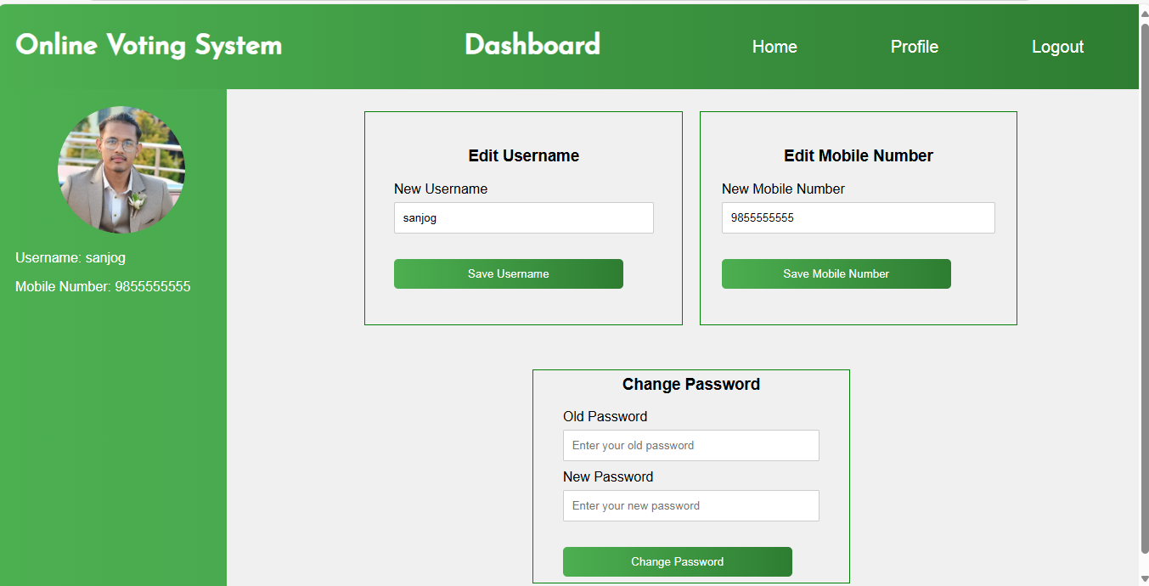

REFERENCES
- https://en.wikipedia.org/wiki/Rooming_house
- "Individual vs Joint Leasing Office of Residence Life Marquette University"
www.marquette.edu. Retrieved 2023-07-21.
- Kalmar, Jessica. "Renting with Roommates: What are Your Lease Options?"
LawDepot Blog. Retrieved 2023-07-21.

